|  |  |  |  |
| --- | --- | --- | --- |
| **Roll No: 113** | **Name:Harshita Shetty** | **Div: B** | **Batch: B2** |

**Experiment No.:2 BLUETOOTH**

**Aim:** To implement a Bluetooth network with the application for the transfer of a file from one device to another.

**Theory:**

Bluetooth is a [wireless t](https://en.wikipedia.org/wiki/Wireless)echnology standard used for exchanging data between fixed and mobile devices over short distances using [UHF](https://en.wikipedia.org/wiki/Ultra_high_frequency) [radio waves i](https://en.wikipedia.org/wiki/Radio_wave)n the [industrial, scientific and medical radio bands, f](https://en.wikipedia.org/wiki/ISM_band)rom 2.402 GHz to 2.480 GHz, and building [personal area networks (](https://en.wikipedia.org/wiki/Personal_area_network)PANs). It was originally conceived as a wireless alternative to [RS-232 d](https://en.wikipedia.org/wiki/RS-232)ata cables.

Bluetooth is managed by the [Bluetooth Special Interest Group](https://en.wikipedia.org/wiki/Bluetooth_Special_Interest_Group) (SIG), which has more than 35,000 member companies in the areas of telecommunication, computing, networking, and consumer electronics. The [IEEE](https://en.wikipedia.org/wiki/Institute_of_Electrical_and_Electronics_Engineers) standardized Bluetooth as IEEE 802.15.1, but no longer maintains the standard. The Bluetooth SIG oversees the development of the specification, manages the qualification program, and protects the trademarks. A manufacturer must meet [Bluetooth SIG standards t](https://en.wikipedia.org/wiki/Bluetooth_Special_Interest_Group#Qualification)o market it as a Bluetooth device.

Transfer of words between two phones using Bluetooth is done below.

**Code:**

**Main_Activity.java:**

package com.santossingh.bluetoothfiletransfer; import android.app.Dialog;

import android.bluetooth.BluetoothAdapter; import android.content.Intent; import android.content.pm.PackageManager; import android.content.pm.ResolveInfo; import android.net.Uri; import android.os.Environment;

import androidx.appcompat.app.AppCompatActivity;

import android.os.Bundle; import android.view.Menu; import android.view.MenuItem; import android.view.View; import android.widget.AdapterView; import android.widget.ArrayAdapter; import android.widget.Button;

import android.widget.EditText; import android.widget.ListView; import android.widget.TextView;

import android.widget.Toast;

import java.io.File; import java.util.ArrayList;

import java.util.List;

public class MainActivity extends AppCompatActivity {

//Create Objects------------------------------------------------------- Button buttonopenDailog, buttonUp, send;

TextView textFolder; EditText dataPath;

static final int CUSTOM_DIALOG_ID = 0;

ListView dialog_ListView; File root, fileroot, curFolder; private List<String> fileList = new ArrayList<String>(); private static final int DISCOVER_DURATION = 300;

private static final int REQUEST_BLU = 1;

BluetoothAdapter btAdatper = BluetoothAdapter.getDefaultAdapter();

//---------------------------------------------------------------

@Override

protected void onCreate(Bundle savedInstanceState) { super.onCreate(savedInstanceState); setContentView(R.layout.activity_main); dataPath=(EditText)findViewById(R.id.FilePath); buttonopenDailog= (Button) findViewById(R.id.opendailog); send=(Button)findViewById(R.id.sendBtooth);

buttonopenDailog.setOnClickListener(new View.OnClickListener() {

@Override public void onClick(View v) {

dataPath.setText("");

showDialog(CUSTOM_DIALOG_ID);

}

});

root = new File(Environment.getExternalStorageDirectory().getAbsolutePath()); curFolder = root;

send.setOnClickListener(new View.OnClickListener() {

@Override public void onClick(View v) {

sendViaBluetooth();

}

});

}

@Override

protected Dialog onCreateDialog(int id) {

Dialog dialog = null; switch (id) { case CUSTOM_DIALOG_ID:

dialog = new Dialog(MainActivity.this); dialog.setContentView(R.layout.dailoglayout);

dialog.setTitle("File Selector"); dialog.setCancelable(true);

dialog.setCanceledOnTouchOutside(true); textFolder = (TextView) dialog.findViewById(R.id.folder); buttonUp = (Button) dialog.findViewById(R.id.up); buttonUp.setOnClickListener(new View.OnClickListener() {

@Override public void onClick(View v) { ListDir(curFolder.getParentFile());

}

});

dialog_ListView = (ListView) dialog.findViewById(R.id.dialoglist);

dialog_ListView.setOnItemClickListener(new AdapterView.OnItemClickListener() {

@Override

public void onItemClick(AdapterView<?> parent, View view, int position, long id) {

File selected = new File(fileList.get(position));

if (selected.isDirectory()) { ListDir(selected);

} else if (selected.isFile()) { getselectedFile(selected);

} else {

dismissDialog(CUSTOM_DIALOG_ID);

}

} }); break;

}

return dialog;

}

@Override

protected void onPrepareDialog(int id, Dialog dialog) { super.onPrepareDialog(id, dialog); switch (id) { case CUSTOM_DIALOG_ID:

ListDir(curFolder);

break;

}

}

public void getselectedFile(File f){ dataPath.setText(f.getAbsolutePath()); fileList.clear();

dismissDialog(CUSTOM_DIALOG_ID);

}

public void ListDir(File f) { if (f.equals(root)) {

buttonUp.setEnabled(false);

} else {

buttonUp.setEnabled(true);

}

curFolder = f; textFolder.setText(f.getAbsolutePath()); dataPath.setText(f.getAbsolutePath());

File[] files = f.listFiles(); fileList.clear(); for (File file : files) { fileList.add(file.getPath());

}

ArrayAdapter<String> directoryList = new ArrayAdapter<String>(this, android.R.layout.simple_list_item_1, fileList);

dialog_ListView.setAdapter(directoryList);

}

//exit to application--------------------------------------------------------------------------- public void exit(View V) { btAdatper.disable();

Toast.makeText(this,"*** Now Bluetooth is off... Thanks.

***",Toast.LENGTH_LONG).show();

finish(); }

//Method for send file via bluetooth------------------------------------------------------------ public void sendViaBluetooth() { if(!dataPath.equals(null)){ if (btAdatper == null) {

Toast.makeText(this, "Device not support bluetooth", Toast.LENGTH_LONG).show();

} else {

enableBluetooth();

}

}else{

Toast.makeText(this,"Please select a file.",Toast.LENGTH_LONG).show();

}

}

public void enableBluetooth() {

Intent discoveryIntent = new

Intent(BluetoothAdapter.ACTION_REQUEST_DISCOVERABLE);

discoveryIntent.putExtra(BluetoothAdapter.EXTRA_DISCOVERABLE_DURATION, DISCOVER_DURATION);

startActivityForResult(discoveryIntent, REQUEST_BLU);

}

//Override method for sending data via bluetooth availability--------------------------

@Override

protected void onActivityResult(int requestCode, int resultCode, Intent data) {

if (resultCode == DISCOVER_DURATION && requestCode == REQUEST_BLU) {

Intent i = new Intent();

i.setAction(Intent.ACTION_SEND);

i.setType("*/*");

File file = new File(dataPath.getText().toString());

i.putExtra(Intent.EXTRA_STREAM, Uri.fromFile(file));

PackageManager pm = getPackageManager();

List<ResolveInfo> list = pm.queryIntentActivities(i, 0); if (list.size() > 0) {

String packageName = null; String className = null;

boolean found = false;

for (ResolveInfo info : list) {

packageName = info.activityInfo.packageName; if (packageName.equals("com.android.bluetooth")) {

className = info.activityInfo.name;

found = true; break;

}

}

//CHECK BLUETOOTH available or not------------------------------------------------ if (!found) {

Toast.makeText(this, "Bluetooth not been found",

Toast.LENGTH_LONG).show();

} else {

i.setClassName(packageName, className); startActivity(i);

}

}

} else {

Toast.makeText(this, "Bluetooth is cancelled", Toast.LENGTH_LONG).show();

}

}

@Override public boolean onCreateOptionsMenu(Menu menu) {

// Inflate the menu; this adds items to the action bar if it is present.

getMenuInflater().inflate(R.menu.menu_main, menu);

return true;

}

@Override public boolean onOptionsItemSelected(MenuItem item) {

// Handle action bar item clicks here. The action bar will // automatically handle clicks on the Home/Up button, so long // as you specify a parent activity in AndroidManifest.xml. int id = item.getItemId();

//noinspection SimplifiableIfStatement

if (id == R.id.action_settings) {

Toast.makeText(this, "****************\nDeveloper: Santosh Kumar

Singh\nContact: superssingh@gmail.com\n****************",

Toast.LENGTH_LONG).show();

return true;

}

return super.onOptionsItemSelected(item);

}

}

**GITHUB LINK:**

**https://github.com/shettyharshita/Mobile_Computing**

**Output:**

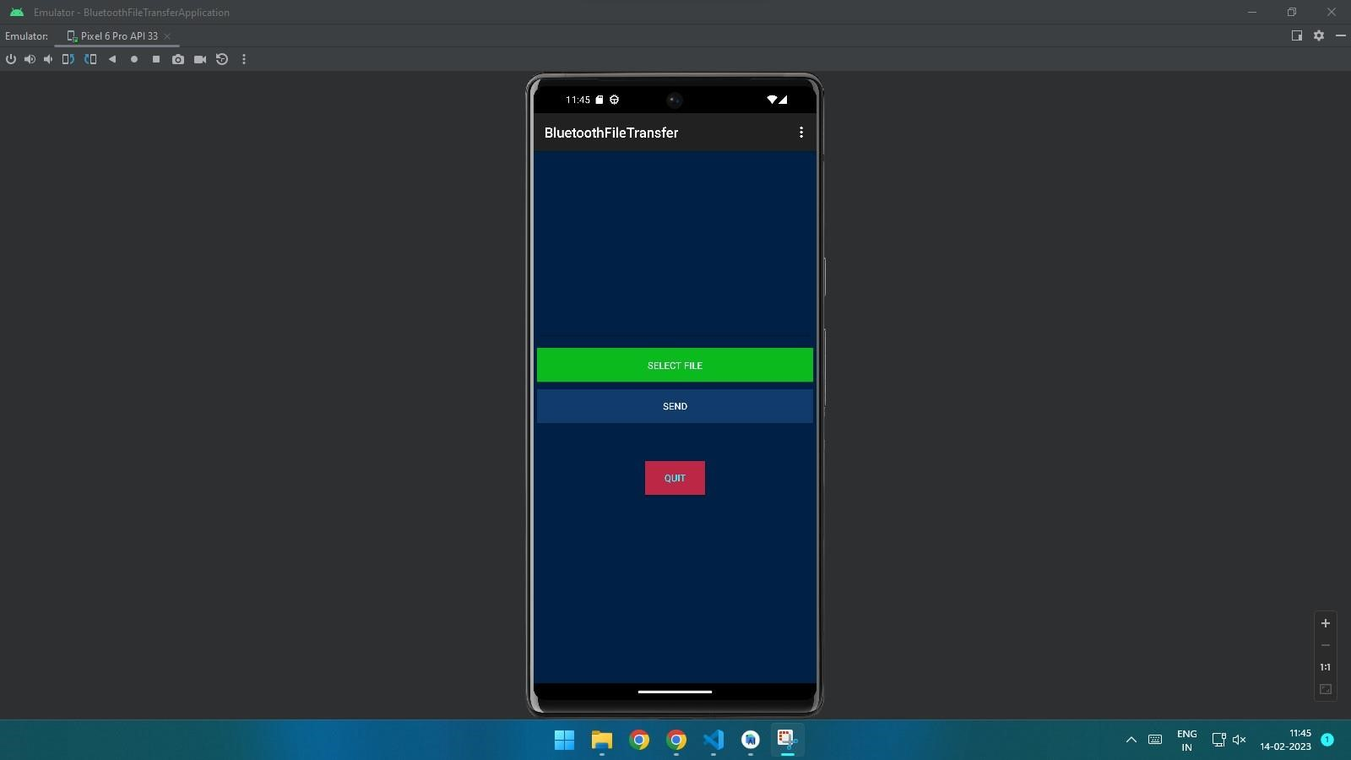

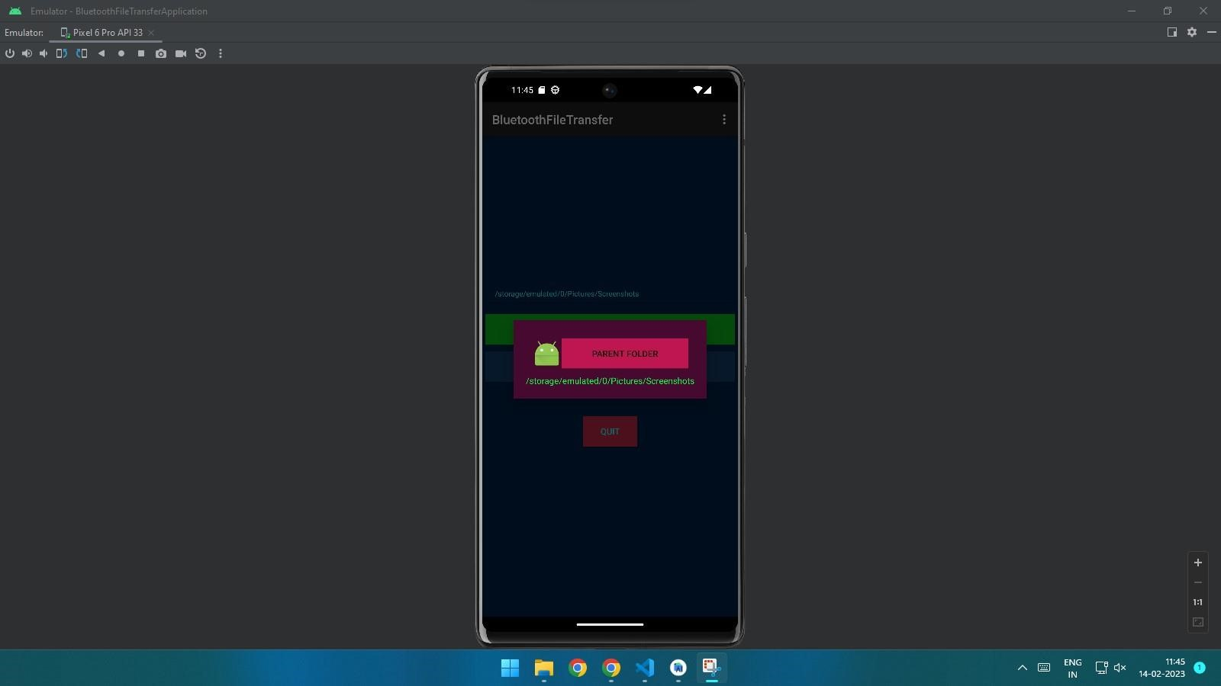

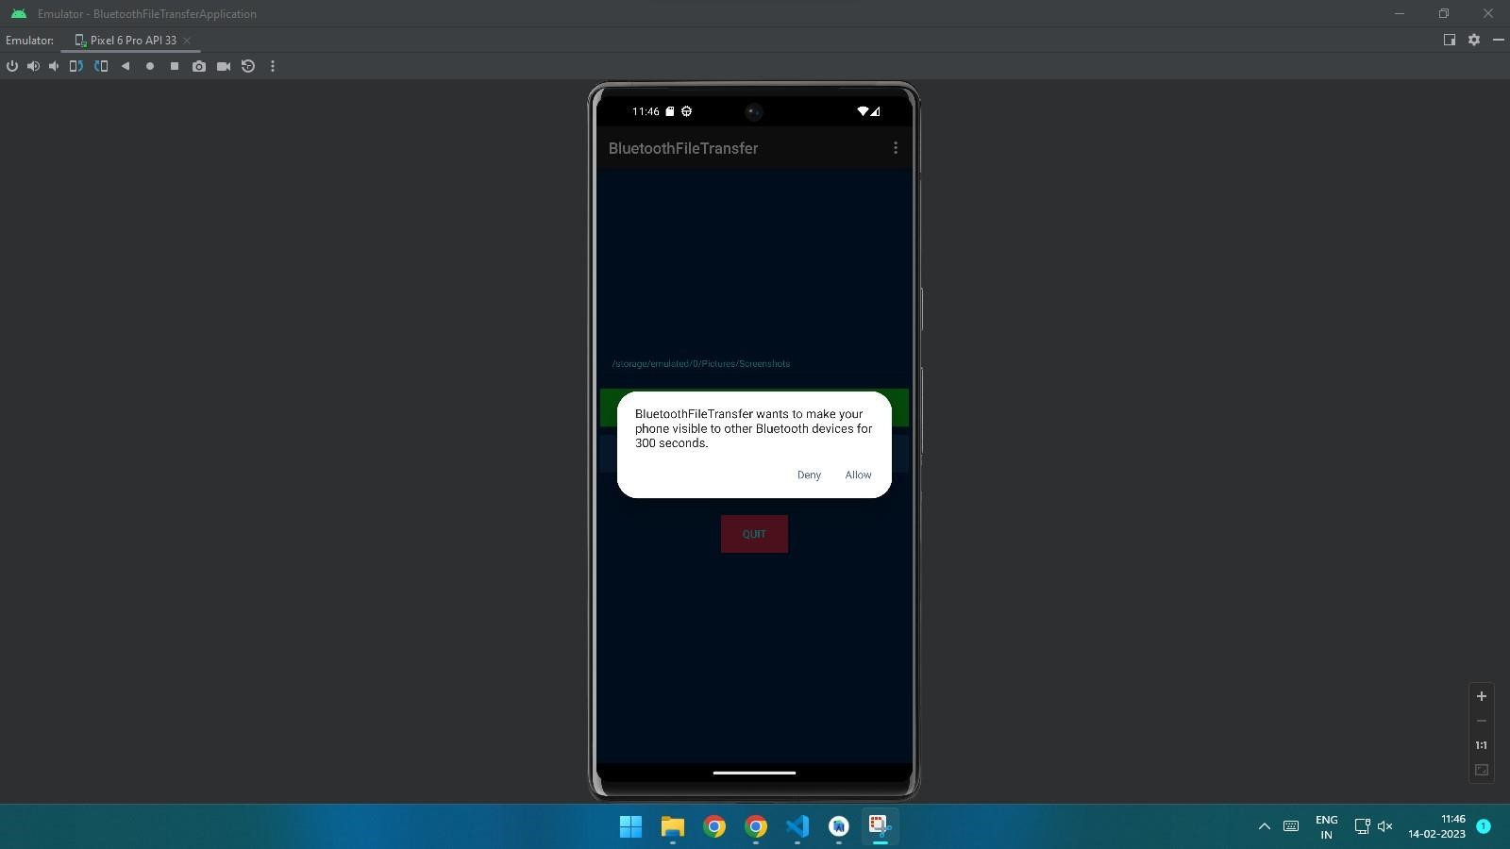

**Conclusion:** Thus, we have successfully performed the experiment of transferring data between two mobile phones using Bluetooth network and after that have checked and it performed.